**Develop The Web Application Using Node-RED**

|  |  |
| --- | --- |
| Date | 09 November 2022 |
| Team ID | PNT2022TMID00354 |
| Project Name | Smart waste management system for metropolitan cities |
| Maximum Marks | 8 Marks |

Aim: Develop the web application using Node-RED Steps Followed:

* Opened a Node-RED project

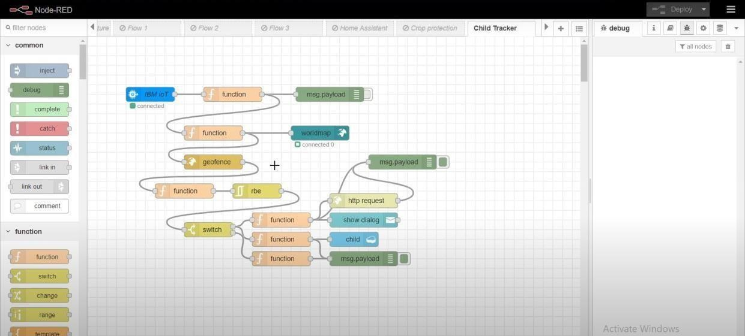

* Added code to get child location in python

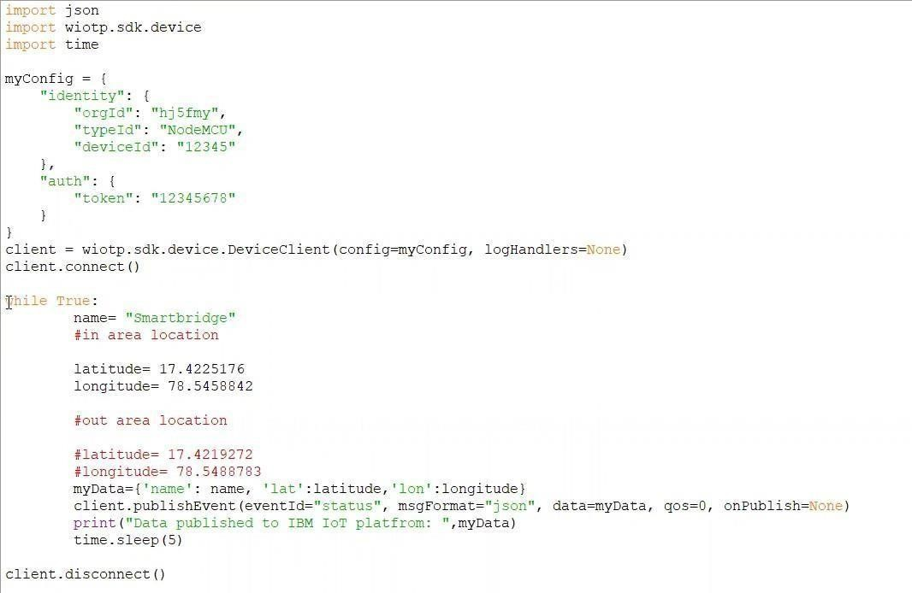

* Editing the HTTP Request URL

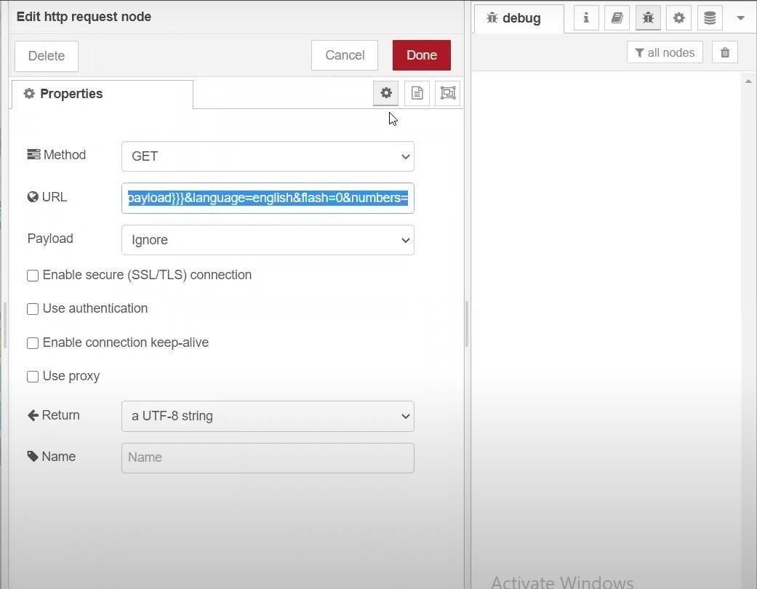

* Located the child

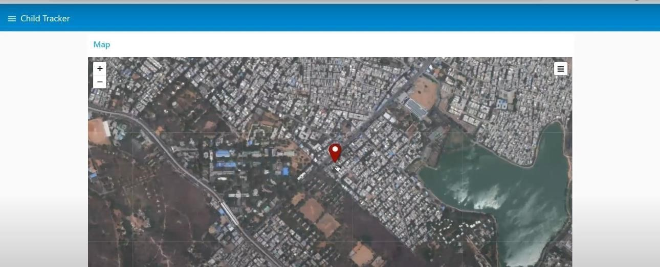

* Python script sending requests to IBM Cloud

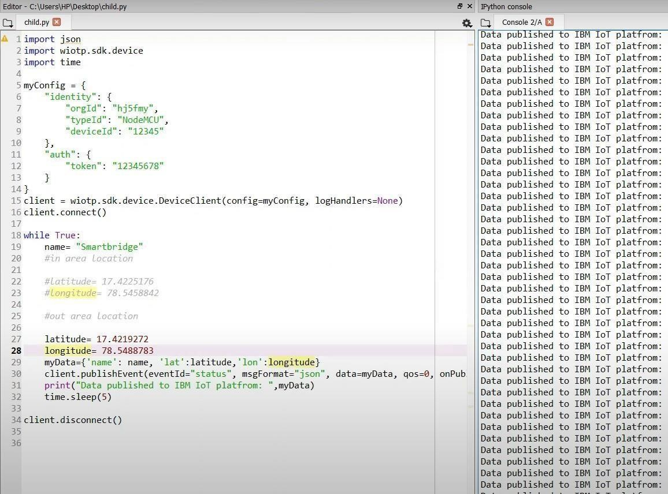

* After running the script, the web UI shows “Person is not in the particular area”

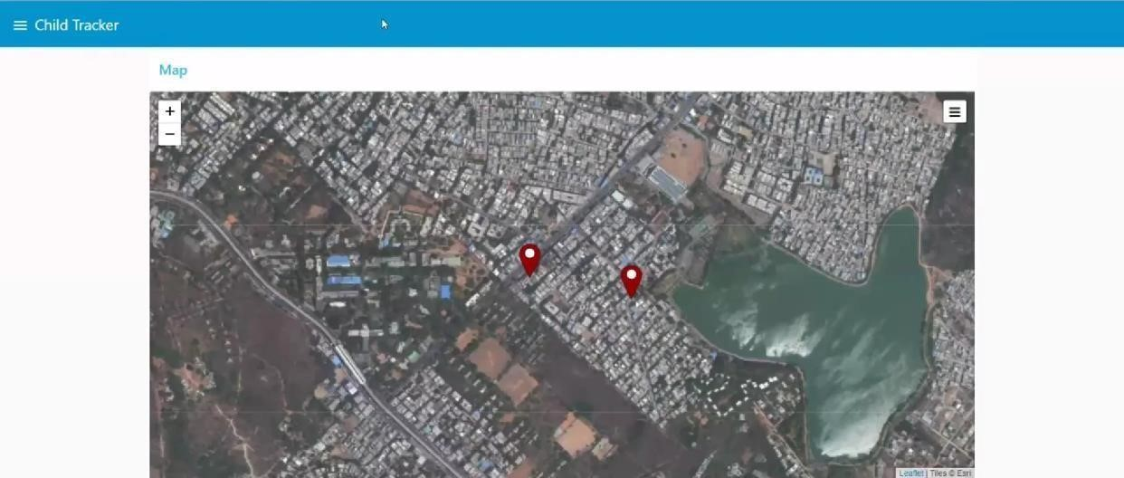

Result: Successfully developed the web application using Node-RED